erv-I-Quip

Service Bulletin
Haskel Refrigerant Pumps, Rev1
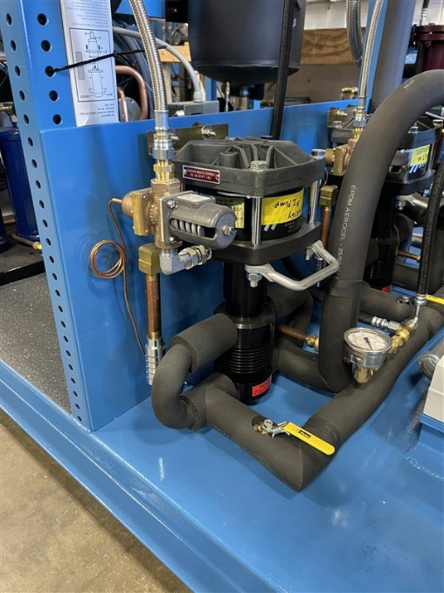

Serv-I-Quip, Inc.
127 Wallace Ave
Downingtown, PA 19335
Phone: (610) 873-7010
Fax: (610) 873-7151

Table of Contents
1.0 Introduction - 1 -
2.0 Lubrication of the Haskel Cycling Valve Spool - 2 -
2.1 Remove muffler - 2 -
2.2 Remove spool retainer - 3 -
2.3 Remove spool from pump - 4 -
2.4 Omron Safety Relay - 4 -
2.4 Cleaning spool and spool retainer - 4 -
2.5 Install new lubricant to spool valve and retainer - 5 -

1.0 Introduction

Haskel HLB Liquid pumps require periodic maintenance based on the runtime of the pump and extended continuous periods of use. The main required maintenance item, which will be detailed in this bulletin, is the lubrication of the cycling valve spool. A lack of maintenance will result in a dried-out spool valve, eventually leading to wear of the spool, pilots stems, and ultimately failure of the pump.
Haskel recommends that the cycling valve spool should be lubricated every 20,000 cycles. The machine pump cycle/min and runtime will help to determine how frequently the PM should be performed and should be considered for each application. A heavy usage system may require weekly PM’s, however low usage system may only require the PM to be performed every 3-6 months. Do not exceed 80 cycles/min. Please refer to “Haskel Suggested Maintenance“ for more detail.
Dryer air will dry out the cycling valve spool at a quicker rate, so this should be considered in determining the frequency of the lubrication PM as well. Haskel recommends a Class 5 or better ISO quality air supply for Haskel air motors. Please see “Haskel Air Quality Recommendations” for more detail.

2.0 Lubrication of the Haskel Cycling Valve Spool

This portion of the bulletin will cover the lubrication of the cycling valve spool as prescribed by Haskel. It is important to note that clean tools and a clean working surface are required when removing, lubricating, and installing the valve spool. Any debris introduced to the cycling valve section of the pump can lead to premature wear and pump failure.

2.1 Remove muffler

Remove the muffler and brass pipe nipple (if present) from the pump exhaust assembly. Use pipe wrench if necessary.
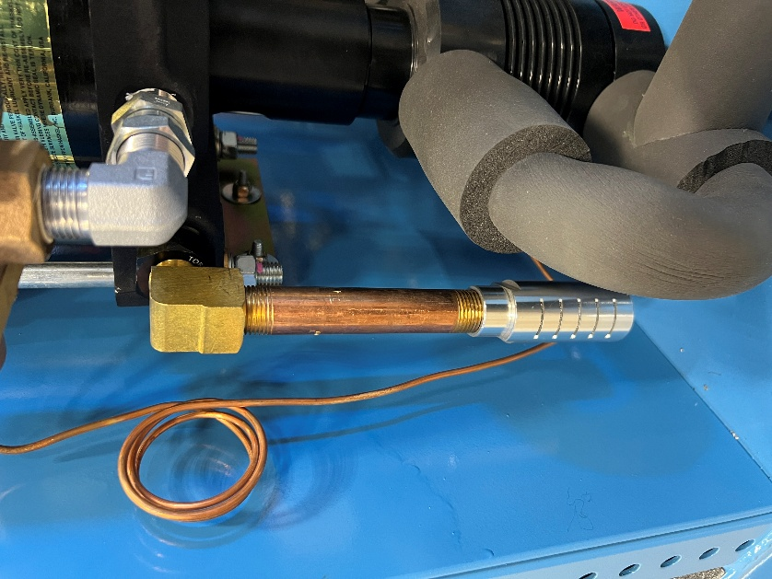
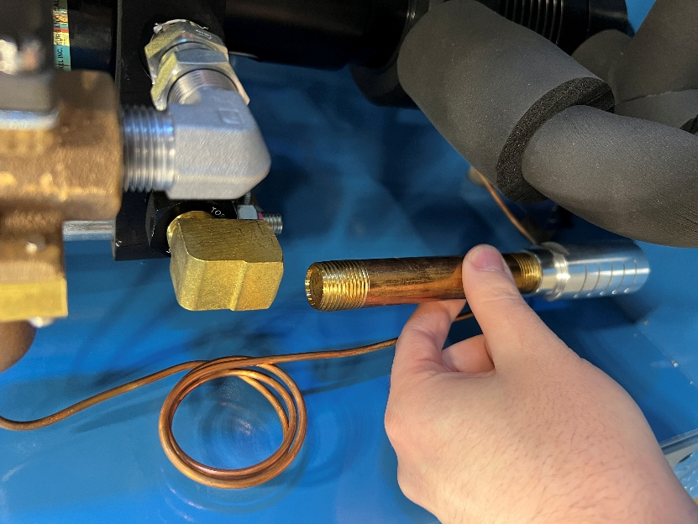

2.2 Remove spool retainer

With an adjustable wrench, remove the spool retainer and street elbow from the pump.
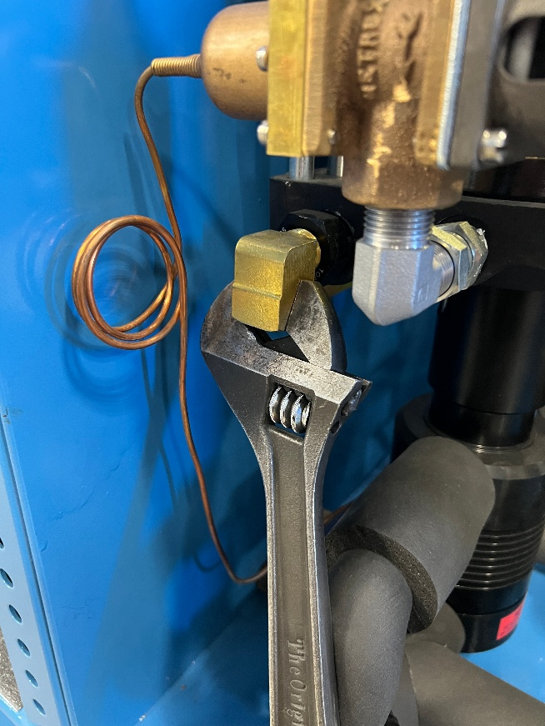
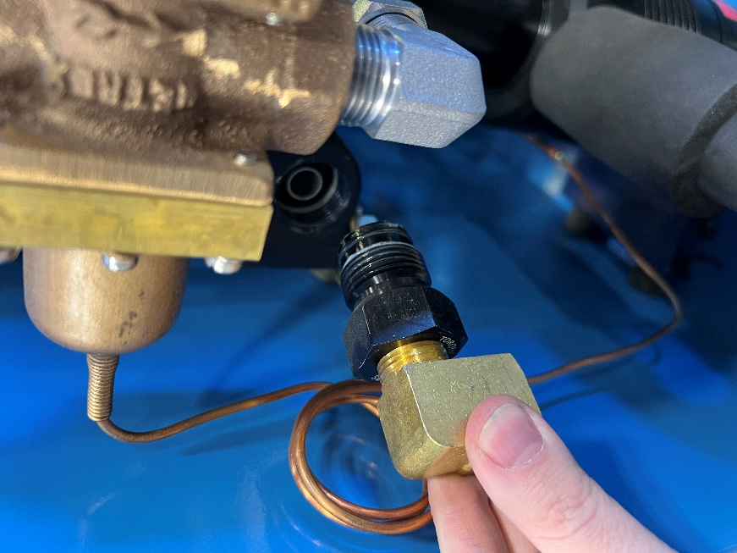

2.3 Remove spool from pump

Using a set of needle nose plyers, carefully remove the spool from the pump.
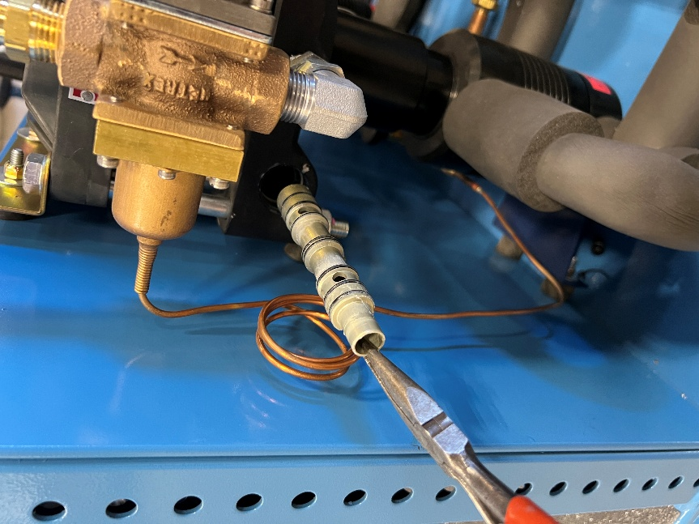
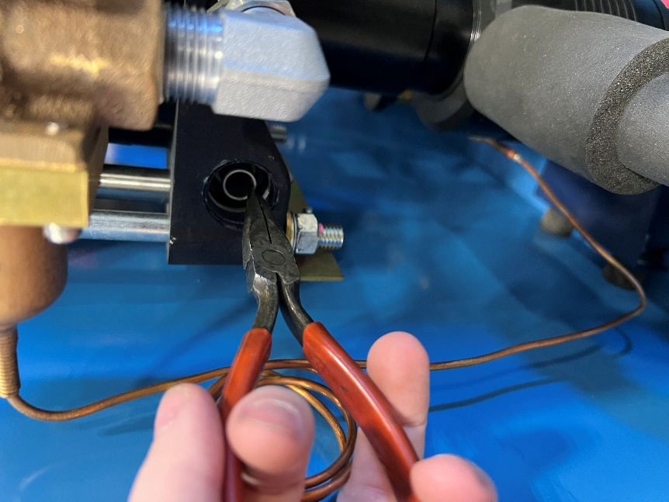

2.4 Omron Safety Relay

2.4 Cleaning spool and spool retainer

Clean all removed parts with a residue free cleaning agent. Inspect all o-rings for tears or abnormal wear. Replace as necessary

2.5 Install new lubricant to spool valve and retainer

Using Novaguard 03-G321-05T lubricant, apply over spool, spool o-rings, and spool retainer as shown.
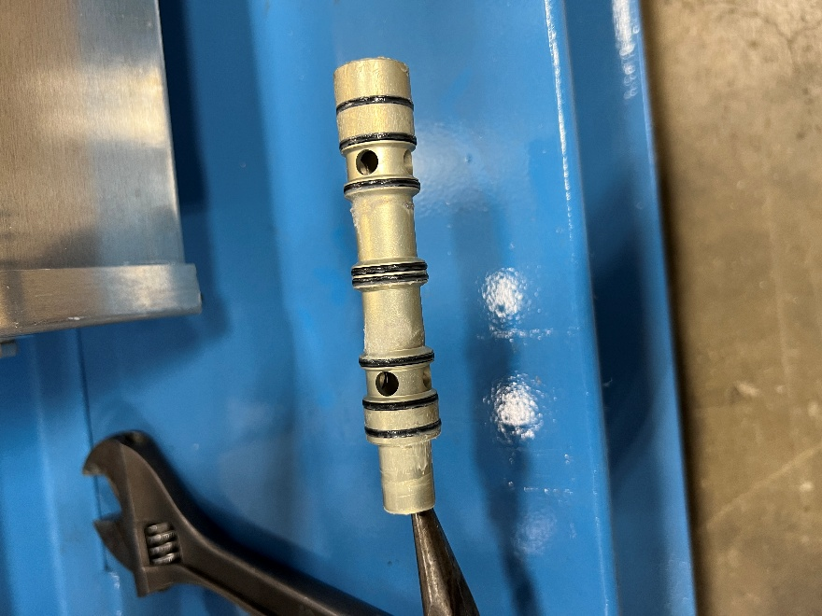
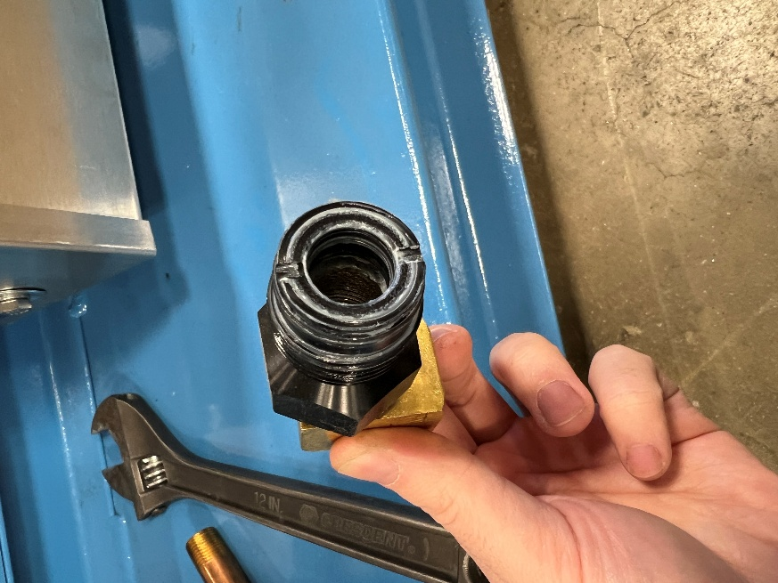

2.6 Install spool valve into pump

Reversing the steps of 2.3 and 2.2, carefully insert the spool valve into the pump. Install the retainer over the spool valve. * Note: Torque spec for spool valve retainer is 50-75 INCH-LBS, exceeding this spec can result in damage to the pilot stems and improper functioning of the pump.

